Data Model and Relationship Design in Power BI
1. Power BI Auto-Created Data Model
In the first image, the data model represents the initial schema automatically created by Power BI after loading the datasets. The model follows a star-schema–like structure, where fact tables are connected to multiple dimension tables.
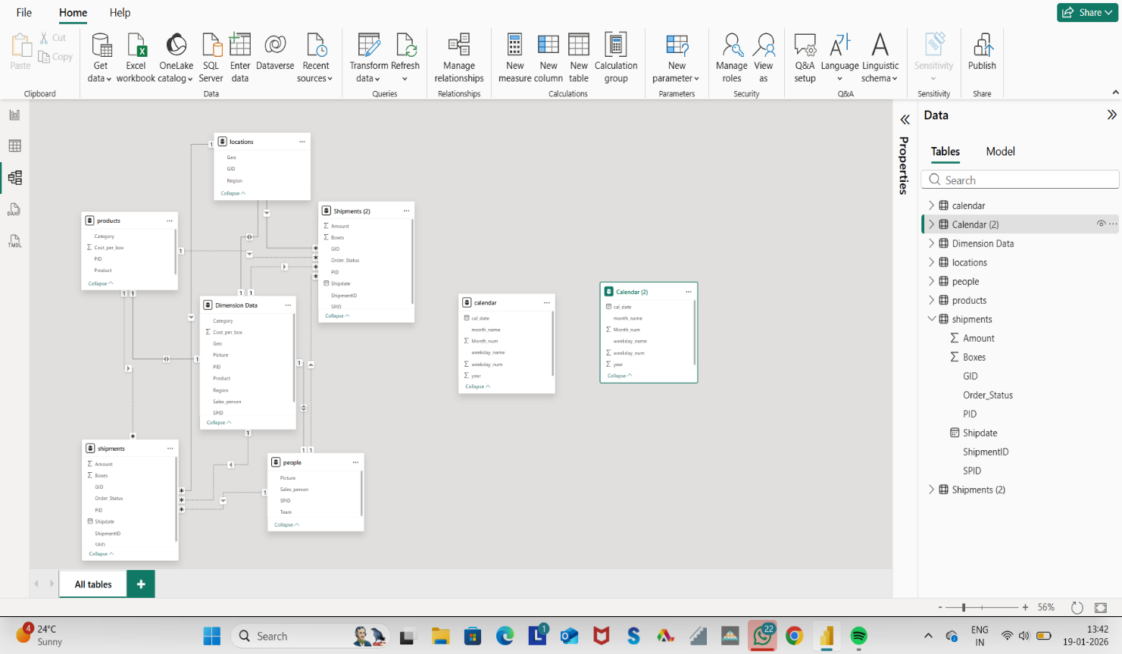
Key Tables:
- Shipments / Shipments (2) – Fact tables containing transactional data such as:
  - Amount
  - Boxes
  - Order Status
  - Shipdate
  - Product ID (PID)
  - Salesperson ID (SPID)
- Dimension Tables:
  - Products – Product details and cost per box
  - People – Salesperson and team information
  - Locations – Geographic data (Region, Geo)
  - Dimension Data – Combined descriptive attributes
  - Calendar – Date-related attributes (Year, Month, Weekday)
Relationships:
- One-to-many (1:*) relationships exist between:
  - Products → Shipments
  - People → Shipments
  - Locations → Shipments
  - Calendar → Shipments
- Filters flow from dimension tables to fact tables, ensuring correct aggregation in reports.
This model allows analysis such as:
- Sales by product
- Shipments by region
- Performance by salesperson
- Time-based trends using a single calendar table

2. Custom Relationship Model Using Calendar & Calendar (2)
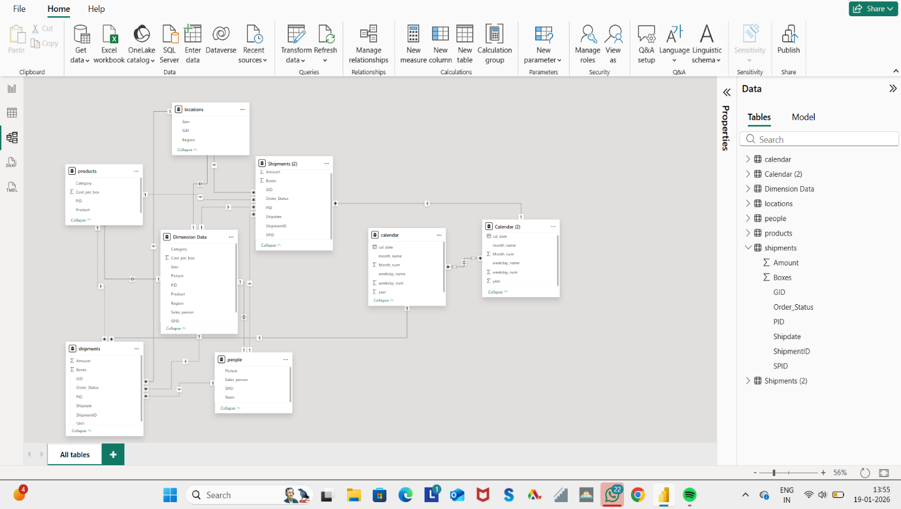

In this image, the data model is enhanced manually by creating two separate date relationships:
- Calendar → Shipments
- Calendar (2) → Shipments (2)
This approach is used when multiple date fields or fact tables must be analyzed independently.
Purpose of Using Two Calendar Tables:
- To avoid ambiguity and filter conflicts
- To analyze different shipment datasets or date contexts separately
- To improve clarity and flexibility in reporting
Example Use Cases:
- Calendar → Shipments
→ Used for overall shipment analysis
- Calendar (2) → Shipments (2)
→ Used for comparison, secondary analysis, or alternative date logic
Each calendar table contains:
- Date
- Month name and number
- Weekday name and number
- Year
By separating the relationships:
- Time intelligence functions (YTD, MTD, YoY) work accurately
- Cross-filtering remains controlled
- Reports become easier to scale and maintain

3. Advantages of This Modelling Approach
- ✔ Eliminates ambiguity in date filtering
- ✔ Supports advanced time-based analysis
- ✔ Improves report accuracy and performance
- ✔ Enables comparison between multiple shipment datasets
- ✔ Follows Power BI best practices for complex models

Conclusion
The first model demonstrates Power BI’s default relational structure, suitable for basic analysis.
The second model represents an optimized and scalable design, where multiple calendar tables are used to handle separate fact tables, ensuring precise and flexible reporting.

